Present Simple - Passive
The passive is used when the object of a sentence is more important than the subject.
Compare:
The Queen rules Great Britain (Active)
Great Britain is ruled by The Queen (Passive)
To form the passive we use 'To Be' + past participle make/made/made
Make passive sentences from the following information:
1. Fiat cars \ Italy \ make –
2. Spaghetti \ boiling water \ cook -
3. Children \ schools \ educate -
4. Football \ every country \ play –
5. Race horses \ jockeys \ ride –
6. Switzerland \ speak \ German –

Past Simple - Passive
James Cameron directed Titanic (Active)
Titanic was directed by James Cameron (Passive)
Make passive sentences from the following information:
1. 1937 \ ballpoint pen \ invent-
2. hospital \ open \ The Queen \ last week –
3. car \ steal \ last night –
4. what time \ he \ attack? –
5. we \ meet \ at the airport \ tour guide-

Simple Future Passive

Something done by someone in the future. ( will be + past participle)
Active : We will take the horses to the stable.
Passive: The horses will be taken to the stable.
Active : Will the manager sign the contract tomorrow?
Passive: Will the contract be signed by the manager tomorrow?

- Will he pick up the kids tomorrow?
Passive:

- The birds will eat those cookies.
Passive:

- The coach will throw a party on the weekend.
Passive:
4. The next earthquake will destroy the city.
Passive:
Useful words for the next exercise:
valve assembly-
hose-
clamp-
spring–
vacuum gauge-
lubrication-
mount-
bolt-
washer-
shaft-
pulley-
belt-
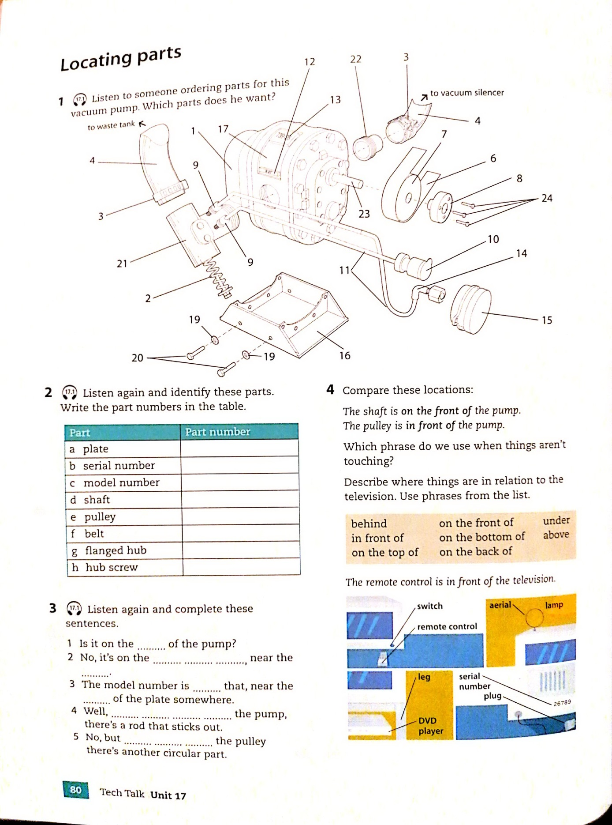

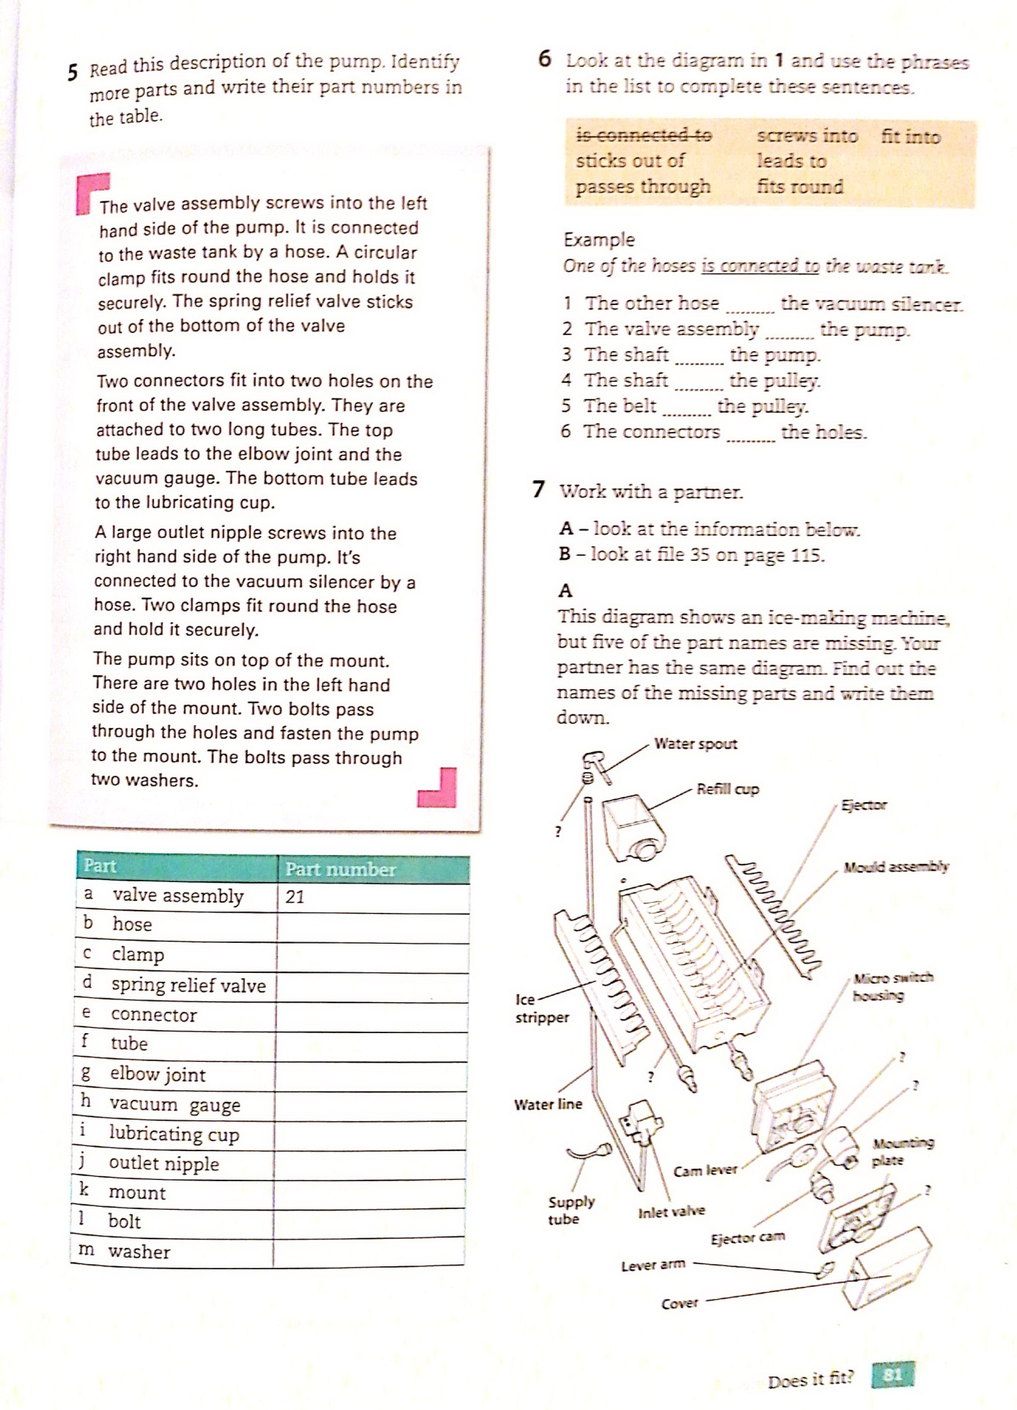

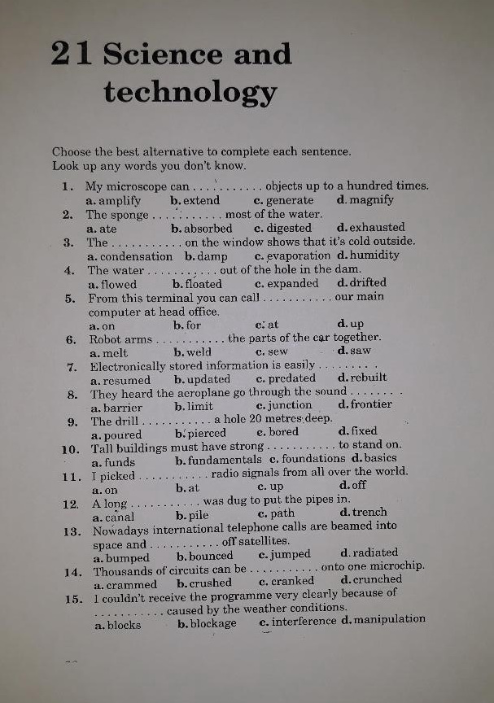
Key: 1) d, 2) b, 3) a, 4) a, 5) d, 6) b, 7) b, 8) a, 9) c, 10) c, 11) c, 12) d, 13) b, 14) a, 15) c.

